**Main Text Figures**



**Figure 1: Murine model of persistent *C. difficile* colonization**

**A.** Change in weight relative to day of infection in infected and mock challenged mice. Points represent median weight; bars are the upper and lower quartiles. Infected mice are colored blue (n=14) while data from mock-infected animals are shown in tan (n=8). Following correction for multiple comparisons, weight loss in infected mice was only significantly different than mock-challenged mice on days 4, 5, and 6 post-infection, p< 0.05. **B.** *C. difficile* colonization over time as determined by quantitative culture. Colonization significantly decreased and remained significantly lower by day 10 post-infection relative to day 1 post-infection 40 (n=14), p< 0.01. The hashed line represents the limit of detection of 100 CFU/g feces. **C.** Relative abundance of OTU 4 (*C. difficile*) over the course of the experiment (blue line) is plotted on the left axis while Shannon diversity of the infected mice over the course of the experiment is plotted on the right axis (black box plots). **D.** Fecal toxin activity remains detectable throughout the experiment. Toxin titer on day 33 and day 40 are significantly different from day 1 post-infection levels (n=14), p<0.05. Statistical significance for all data was calculated using a Wilcoxon test with a Benjamin- Hochberg correction for multiple comparisons. The hashed line represents the limit of detection (LOD) for each assay, for visual clarity samples that were below the limit of detection were plotted below the line. However, for statistical analysis, the value of LOD/√2 was substituted for undetected values.

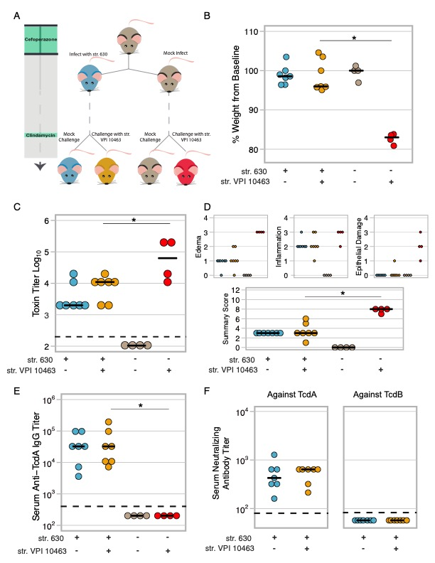

**Figure 2: Mice pre-colonized with *C. difficile* strain 630 are protected from challenge with a lethal strain A.** Schematic of experimental conditions. Colors corresponding to treatment groups are carried throughout the figure. **B.** Change in weight at time of necropsy relative to weight on day of challenge. Mice colonized with *C. difficile* strain 630 and challenged with the lethal strain (VPI 10463) (n=4) are protected from weight loss whereas mice that had no exposure to *C. difficile* strain 630 experienced significant weight loss (n=4), p< 0.01. **C.** Toxin titer from intestinal content from mice in panel A as measured by Vero cell rounding assay. Mice colonized with *C. difficile* strain 630 and then challenged with *C. difficile* strain VPI 10463 have a lower toxin titer relative to naïve mice challenged with VPI 10463, p< 0.05. **D.** Histopathology from colons of the mice in panel A. Small panels depict scores for each component that makes up the summary score. Summary score of VPI challenged 630 colonized vs. VPI challenged naive mice p< 0.01. **E.** Titer of serum IgG against TcdA at conclusion of experiment as measured by ELISA. Limit of detection was a titer of 400, p< 0.01. **F.** Neutralizing titer of serum against TcdA or TcdB. For all data statistical significance between the *C. difficile* strain VPI 10463 challenged strain 630-colonized and VPI 10463 challenged naive mice was determined by Wilcoxon test. The hashed line represents the limit of detection for each assay, for visual clarity samples that were below the limit of detection were plotted below the line.



**Figure 3: RAG1-/- mice pre-colonized with *C. difficile* are protected from challenge with a lethal strain of *C. difficile***

**A.** Change in weight at time of necropsy relative to weight on day of challenge. Both WT and RAG1-/- mice colonized with strain 630 and then challenged with the highly virulent strain VPI 10463 are protected from weight loss whereas mice that had no exposure to strain 630 experienced significant weight loss, VPI challenged 630 colonized RAG1-/- vs. VPI challenged naive RAG1-/- p<0.05, VPI challenged 630 colonized WT vs. VPI challenged naive WT p<0.01, no statistical difference was detected in comparisons of the same treatment between the two genotypes. **B.** Toxin titer from intestinal content of mice in figure A as measured by Vero cell rounding assay. Both WT and RAG1-/- mice colonized with strain 630 and then challenged with VPI 10463 have a lower toxin titer relative to naïve mice challenged with VPI 10463, 630 colonized RAG1-/- vs. naive RAG1-/- p<0.05, 630 colonized WT vs. naive WT p<0.001. Statistical significance was calculated using a Wilcoxon test. Limit of detection was 2.3, however for visual clarity samples with an undetected toxin titer were plotted below the limit of detection. **C.** Histopathology scoring of the colons of mice in A. Small panels depict scores for each component that makes up the summary score. Summary scores of VPI challenged 630 colonized RAG1-/- vs. VPI challenged naive RAG1-/- p<0.05, VPI challenged 630 colonized WT vs. VPI challenged naive WT p<0.001. For all panels, statistical significance was calculated using a Wilcoxon test with a Benjamini-Hochberg correction for multiple comparisons. Data are from two independently run experiments with multiple cages per each treatment group. Each point represents a mouse.



**Figure 4: *C. difficile* strain 630 protects by limiting colonization of the lethal strain.**

**A.** Change in weight at time of necropsy relative to weight on day of challenge in mice pre-treated with viable strain 630, heat-killed strain 630 or water (mock). All mice were infected with strain VPI 10463 one day following pre-treatment. Both RAG1-/- or WT mice given viable strain 630 did not lose weight following challenge with strain VPI 10463 when compared to mice who received heat-killed strain 630 or water (mock), p<0.05 for all comparisons shown. **B**. Levels of strain 630 in mice at conclusion of experiment (630 is erythromycin resistant while VPI 10463 is sensitive to the antibiotic). Colonization by strain 630 was significantly different in mice given viable 630 compared to mice given heat-killed 630 or mock. RAG1-/- mice given 630 vs. heat-treated 630, p < 0.05 or vs. mock, p < 0.05. WT mice given 630 vs. heat-treated 630, < 0.05 or vs. mock, p < 0.05. There was no significant difference between colonization in the mock vs. heat-killed 630 treatments for either genotype. LOD is 100 CFU/g feces; undetected samples were plotted below the LOD for visual clarity. **C.** Total levels of *C. difficile* colonization at conclusion of experiment. There was no significant difference in total *C. difficile* colonization between any of the groups, p>0.7. **D.** CFU equivalents of strain VPI 10463 in gnotobiotic mice as determined by qPCR. Mice pre-colonized with *C. difficile* strain 630 have undetectable levels of strain VPI 10463 using this assay, LOD is 1.39 x104 CFU, levels of VPI 10463 in 630 pre-colonized mice vs. VPI 10463 only mice p < 0.01. **E**. CFU/gram of feces of *C. difficile* strain 630 in gnotobiotic across groups as determined by selective quantitative culture Mice only challenged with VPI 10463 were not colonized with strain 630. LOD is 1000 CFU, p < 0.05. **F.** Total CFU/gram of feces of *C. difficile* in gnotobiotic as determined by quantitative culture. **G.** Mice challenged simultaneously with both strains can be colonized by both strains. Left axis represents Log10 CFU of total *C. difficile* (closed circle) or strain 630 two days post challenge (open circle). Right axis depicts percent of baseline weight two days post challenge (triangle). Each different inoculum ratio was given to one cage of five mice. Points represent the median value for each treatment while the bars represent the upper and lower quartiles. For all panels in the figure, squares represent RAG1-/- mice while circles represent wild-type (WT) mice. For the data included in each figure, statistical significance was calculated using a Wilcoxon test and corrected for multiple comparisons with a Benjamini- Hochberg correction. The hashed line represents the limit of detection for each assay, for visual clarity samples that were below the limit of detection were plotted below the line.



**Figure 5: Colonization with *C. difficile* strain 630 significantly reduces the co-germinant glycine in cecal contents, leading to reduced germination of invading strain.**

**A**. Spent cecal media from 24hrs growth of str. 630 *ex vivo* supports robust growth of strain VPI 10463. Filter sterilized spent cecal media was inoculated with vegetative strain VPI 10463 and colonization was monitored by quantitative culture at time zero and six hours. Cecal media that grew str .630 a support robust growth of strain VPI 10463. Strain VPI 10463 colonization at t =0 vs. t= 6 hours in 630 spent culture, p< 0.05. Strain VPI 10463 colonization at t =0 vs. t= 6 hours in fresh media, p< 0.01. Strain VPI 10463 colonization at t =0 vs. t= 6 hours in VPI spent culture media, p< 0.01. Data represent two independent experiments using separate batches of cecal media (pooled from at least 6 mice for each batch) run in at least quadruplicates. **B.** Concentration of glycine in cecal media made from cecal contents of mice one-day post infection with *C. difficile* (*C. difficile* D1 CM) compared to cecal media made from mock challenged mice (D1 CM). Data represent values from two separate batches of cecal media per group. **C.** *Ex vivo* germination of VPI 10463 spores in cecal media from panel B. PBS and PBS + 0.1% sodium taurocholate served as negative controls while PBS supplemented with 0.1% sodium taurocholate and 100mM glycine served as a positive control. Dark grey box plots represent both the vegetative and any remaining spores before heating while the light grey box plots represent the heat-resistant spores.

Statistical significance for all comparisons was calculated using a Wilcoxon test with Benjamini- Hochberg correction when appropriate.

**Supplemental Figures**



**Supplemental Figure 1: Effect of clindamycin on weight and colonization levels**

**A**. Change in weight from the day mice were given clindamycin to the following day. Mock-infected mice (or naïve animals) are a reference point. There was not a significant difference between the infected or mock-infected mice following administration of clindamycin, p > 0.05. **B.** *C. difficile* colonization in infected animals one day prior to administration of clindamycin and one day following. Clindamycin significantly increases levels of C. difficile strain 630 in infected mice, p < 0.001. For the data included in each figure, statistical significance was calculated using a Wilcoxon test.



**Supplemental Figure 2: Validation of primers for VPI 10463. A.** Plot of Cq (or crossing-threshold) vs. dilution of genomic DNA from VPI 10463, R2 = 0.9929. **B.** The resulting PCR products formed one melt peak.



**Supplemental Figure 3: *Ex Vivo* growth in Cecal Media.**

**A.** Sterile cecal filtrate from susceptible mice (day 0) was inoculated with vegetative cells of *C. difficile* strain 630, vehicle, or vegetative cells of *C. difficile* strain VPI 10463. Levels of colonization were monitored by quantitative culture at time zero and twenty-four hours. Cecal media supports robust growth of both strains, p< 0.001. Data from A two independent experiments using separate batches of cecal media run in at least quadruplicates. **B**. Growth of *C. difficile* strain VPI 10463 in cecal media made from content from mice infected for twenty-four hours with *C. difficile* strain 630. Strain VPI 10463 colonization at t =0 vs. t= 24 hours, p= 0.02857. Statistical significance for all comparisons was calculated using a Wicoxon test.



**Supplemental Figure 4: Targeted metabolomics measuring amino acids in D1 and 630D1 cecal media.** Concentration of amino acids in cecal media (uM). Statistical significance for all comparisons was calculated using a t-test.